
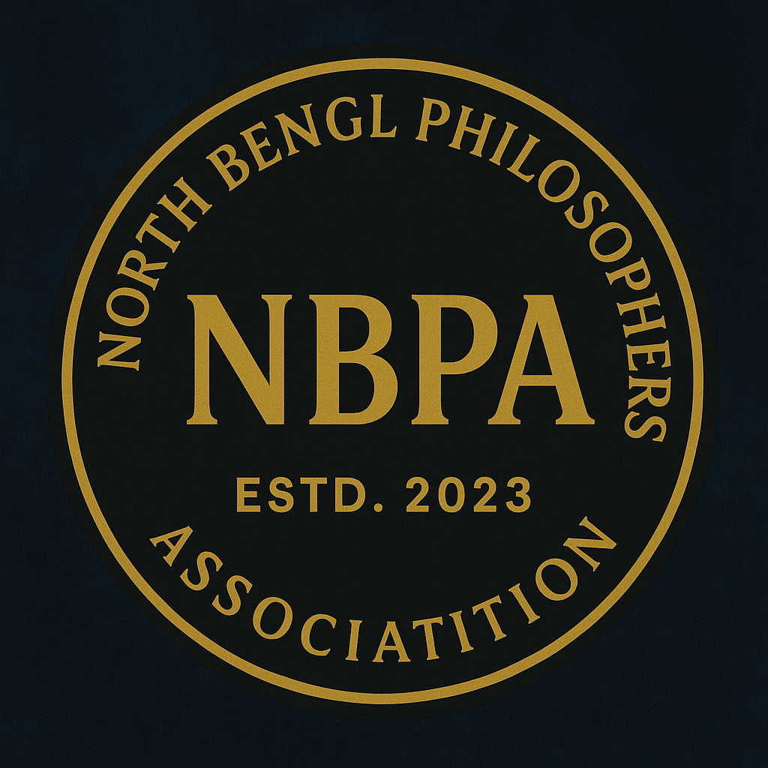
NBPA Journal for Arts, Humanities & Social Sciences
ISSN: 3107-619X (Online)
A Peer-reviewed Multidisciplinary Quarterly Journal

From Knowledge to Emancipation: Vision of Nyāya Philosophy
Manoranjan Prasad Sing
Assistant Professor
Department of Philosophy, Presidency University, Kolkata
Abstract
This paper delves into the core of Nyāya philosophy by exploring the sixteen categories (ṣoḍaśa-padārthas) outlined in Gautama’s Nyāya-sūtra and their pivotal role in achieving liberation (niḥśreyasa). While it provides the fundamentals of the ultimate goal, liberation (niḥśreyasa), it would also provide the foundation for why Nyāya philosophy is not merely a spiritual philosophy but has a longstanding logical set-up for acquiring knowledge. Hence, the paper provides the philosophical and epistemological analysis underpinning the connection of the categories in the Nyāya-sūtra (1.1.1) for true knowledge (pramā) and how true knowledge helps in achieving liberation (apavargaḥ in Nyāya-sūtra-1.1.2 as the ultimate means of inquiry.


Original Article
Open Access
Received: 06.09.2025
Accepted: 26.09.2025
Publication Date: 30 September 2025
Volume: 1
Issue: 2
Doi: 10.5281/zenodo.17244813

Copyrights:

This work is licensed under a Creative Commons Attribution-NonCommercial-No Derivatives 4.0 International License.

Published by: North Bengal Philosophers Association
Website: https://nbpajournal.com/ https://nbpa.org.in/
Key Words: Nyāya-sūtra . mithyājñāna . niḥśreyasa . ṣoḍaśa-padārtha . tattva-jn͂āna

Introduction
Maharshi Gautama, the founder of Nyāya philosophy in his Nyāya-sūtra, provided a way of attaining liberation or niḥśreyasa. We would take an exposition of the concept of the sixteen categories given by Gautama in detail to understand the dynamism of Nyāya's understanding of knowledge. He states that the knowledge of categories leads to the ultimate good. Gautama tried to identify the reason behind birth, death, and suffering in his Nyāya-sūtra-1.1.2. The goal of Nyāya philosophy is to enable us to attain the highest goal of life, which is liberation from suffering. According to the Naiyāyikas, the world presents itself as a chain of consequences that needs to be broken in order to attain liberation from suffering. This is the chain through which one has to pass, i.e., Misapprehension (ajn͂āna) to Imbalance (doṣa) to Activity (karma) to Rebirth (janma) and finally to Suffering (duḥkha). One can break the chain in the same sequence, though this is not the only concern of Nyāya philosophy.
Vātsāyana gave an introduction at the very beginning of the commentary regarding Nyāya-sūtra to define a successful activity, i.e.
Pramānato-artha-pratipattoh
Pravṛitti-sāmartha-arthavat-pramāṇam. (Tarkavāgīśa, 1981, p. 1)
According to him, every successful activity is cognised by the ‘instrument of valid knowledge’ (Pramāṇa). Hence, the instrument of valid knowledge is invariably connected with the cognised object. Without having the instrument of true knowledge, it is impossible to have the cognition of an object, and without having the cognition of an object, it is impossible to have any successful activity. And with the help of an instrument of valid knowledge, the knower decides to get an object or to avoid it. The effort of getting or avoiding a particular object depends on the result because it is up to the person to decide how much is necessary for them. Vātsyāyana mentions the context of the desire to get or avoid a particular object as the only cause of human suffering. However, for an existing human being, it is necessary to be desirous about getting or avoiding a particular object. Therefore, getting an object is supposed to be a pleasure (sukha), but the final effect in the long run is suffering (duḥkha). However, without desire, one cannot perform an activity. An activity is performed by a person only when he knows the nature of an object as it exists. For this reason, every object is known through a valid source (pramāṇa); hence, objects of pramāṇa are innumerable. We know that acquiring knowledge of an object depends on various sources. This is one of the reasons for why we would see all schools of Indian philosophy accept various sources of valid knowledge. In the Nyāya system, Naiyāyikas accepted four pramāṇas (i.e., pratyaksa, anumāna, upamāna, and śabda) through which one can get the true cognition of an object.
Since pramāṇa is invariably related to the object, pramātṛ, prameya, and pramiti are also related in the same way to the object that a person desires. Let us know how these are related. Pramāṇa is a valid source of knowledge. Prāmatṛ is cognised by the person who is guided by the desire to seek or ignore the object, which leads to activity. Therefore, pramāṇa is the instrument through which the knower (pramātṛ) rightly knows the object. Prameya is the object of valid knowledge. Pramiti has the right knowledge of the object. With these four tattvas, one can arrive at one’s desire. If an object is known as positive, then a person must know that object without any contradiction. Then, it becomes tattva, and the process is called sat or bhāva. Again, when a negative object is known as negative, which is its actual nature, too, it becomes tattva, and the process is called asat or abhāva. Thus, objects are classified under two heads: positive (bhāva) and negative (abhāva). Positive objects are those that are determined by pramāṇa as existing, and negative objects are determined by pramāṇa as not existing. Therefore, “being determined by pramāṇa as existing constitutes the intrinsic nature of the positive object or its positivity. Being determined by pramāṇa as not existing constitutes the intrinsic nature of the negative object or its negativity.”(Chattopadhyaya & Gangopadhyaya, 1967, p. 9)
It is well-known that an object must be ascertained by a pramāṇa. Otherwise, it cannot be called an object (padārtha). Here, Vātsyāyana raised a question regarding the negative object. He pointed out that a negative object, too, is a type of object. Then, the question is how to know the negative or asat by a pramāṇa. He resolved the issue by asserting that a similar pramāṇa that reveals the positive object also reveals the negative object. He produced an example to clarify the particular doubt regarding the negative objects. He wrote:
“After the escape of the thief, a mere boy can, with a lamp, find out what is in the room as well as what is not there. What exists is seen, what exists not is not seen; thus, the latter is known as not existent. Such awareness of the non-existent is common to all. Being awareness, it necessarily points an object. The object pointed by it (i.e. by the awareness of the not existent) is the negative object. So, the awareness of something as not existent is the awareness of the negative object.” (Ibid., p. 9)
However, it is Vātsyāyana who classified objects under two heads, namely, the positive and the negative. But Gautama, in his first sūtra regarding sixteen categories, didn’t mention the negative object. That is why later commentators obliged themselves to offer some explanation for Gautama’s silence over the negative objects. And there are two necessary explanations which could be offered. Firstly, the awareness of the negative object is presupposed by the reference to its positive counterpart, and as such, Gautama is primarily concerned with the latter (Ibid., p. 9). Secondly, Gautama discussed only those objects the knowledge of which directly produces the summum bonum (niḥśreyasa) (Ibid., p. 9). Though there are many other objects, the knowledge of which doesn’t lead to the summum bonum. That is why Gautama didn’t mention those objects in his sutra. He also refrained from mentioning the negative objects. However, Phanibhūsana argued that Gautama implicitly mentioned the negative objects: “In the list of sixteen categories occurs prameya (object of knowledge), which includes apavarga. The meaning of apavarga is the absolute non-existence of suffering and as such is a negative object” (Ibid., p. 9). Therefore, in this way, the claim regarding Gautama’s silence about the negative object is resolved.
Gautama’s First Sūtra: An Analysis of Its Essence
Vātsāyana begins his analysis of Gautama’s first sūtra by mentioning that true cognition of the sixteen categories is instrumental to the summum bonum (liberation). The categories that comprise the acquisition of true cognition are:
- Instrument of valid knowledge (Pramāṇa),
- Object of valid knowledge (Prameya),
- Doubt (Saṃśaya),
- Incentive (Prayojana),
- Corroborative Instance (Dṛṣṭānta),
- Proved Doctrine (Siddhānta),
- Inference- components (Avayava),
- Hypothetical Argument (Tarka),
- Final Ascertainment (Nirṇaya),
- Discussion for the final Ascertainment (Vāda),
- Debating Maneuver (Jalpa),
- Destructive Criticism (Vitaṇḍā),
- Pseudo-probans (Hetvābhāsa),
- Purposive Distortion of the opponent (Chala),
- Futile Rejoinder based on mere Similarity or Dissimilarity (Jāti) and
- Point of Defeat (Nigrahasthāna) - (Nyāya-sūtra-1.1.1)
Right knowledge of these categories is conducive to attaining the highest good (Niḥśreyasa). Vātsyāyana took up the discussion by clarifying the structure of the first sūtra given by Gautama. He argued that the summum bonum is obtained by the true cognition of the (twelve) objects of knowledge, namely, ātman, śarira, indriya, etc. This is explained in the second sūtra given by Gautama. Vātsyāyana identified that one can acquire summam bonum by the true cognition of the four human concerns or ‘arthapāda’. These are as follows:
“(i) Suffering (heya, lit. ‘which is to be avoided’) and its cause,
(ii) Right knowledge (ātyantika-hāna, lit. ‘the cause of the absolute cessation of suffering’),
(iii) The means of attaining that right knowledge (i.e., the present sāstra) and
(iv) Liberation (adhigantavyo, lit. ‘the ultimate goal’).” (Ibid., p. 10)
Vātsyāyana’s commentary suggests that four human concerns underlie the ultimate goal of liberation (summum bonum). For this reason, the question arises of whether the categories given by Gautama directly help summum bonum. If so, then how can that be possible, and how is the right knowledge of jalpa, vitandā, or chala directly responsible for the summum bonum? Vātsyāyana's commentary on Gautama's first sūtra argues that the true cognition of the sixteen categories is the path to liberation (summum bonum). However, he makes a crucial distinction: while all sixteen categories are necessary, they do not all contribute to liberation in the same way. He writes- “of these categories, the knowledge of what Gautama technically calls prameya (prameya means object of valid knowledge) is directly conducive to the summum bonum. But Gautama restricts its use to only twelve such objects,” (Ibid., p. 11).
According to Vātsyāyana, the prameya (objects of valid knowledge) are the direct means to liberation. These are the twelve objects of knowledge, such as the ātman (self), śarira (body), and indriya (senses), which are described in Gautama's second sūtra. It is the direct knowledge of these specific prameyas that leads to the cessation of suffering and the attainment of the highest good (niḥśreyasa). The other fourteen categories (e.g., jalpa, vitandā, and chala) are considered indirect causes of liberation. These categories serve as tools to establish the truth and refute false arguments. Therefore, their role is to protect and support the valid knowledge of the prameya. In essence, they are instrumental to the ultimate goal, but they are not the goal itself.
Following the above interpretation, there might be challenges that can arise from Vātsyāyana's commentary on the point that the original sūtra (1.1.1) does not explicitly state that the prameya is a direct cause and the other categories are indirect. This raises the question of whether Vātsyāyana’s interpretation is truly what Gautama intended. I support the interpretation that Vātsyāyana’s commentary provides a structured framework for understanding Gautama’s sūtra. Even if we acknowledge the interpretive gap, his analysis helps to resolve the apparent contradiction of how categories like Jalpa, Vitandā, and Chala help us gain knowledge of the prameyas. By establishing the direct and indirect relationship, Vātsyāyana offers a logical and coherent explanation that makes the entire system of categories intelligible within the context of attaining summum bonum. Thus, understanding the significance of these categories requires attention to Vātsyāyana’s nuanced and clarifying commentary.
The Significance of Categories in Gautama's Nyāya-sūtra-1.1.1
In Nyāya philosophy, pramāṇa (valid means of knowledge) and prameya (objects of knowledge) are central to knowledge acquisition and the attainment of apavarga (liberation). Pramāṇa refers to the reliable instruments through which true knowledge is acquired, namely perception (pratyakṣa), inference (anumāna), comparison (upamāna), and verbal testimony (śabda). These serve as the means to dispel mithyājñāna (false cognition), the root cause of bondage and rebirth. Prameya includes twelve fundamental objects of knowledge, such as self (ātman), body (śarīra), senses (indriya), objects of the senses (artha), knowledge (buddhi), mind (manas), activity (pravṛtti), defects (doṣa), rebirth (pretyabhāva), result (phala), suffering (duḥkha), and liberation (apavarga). Right cognition of these objects enables one to negate ignorance, overcome doṣa, and break the cycle of action, birth, and suffering. Thus, the interplay of pramāṇa and prameya provides the epistemic pathway to apavarga, the ultimate cessation of suffering. While pramāṇa and prameya are the direct determinants of apavarga, the inclusion of other categories makes the Nyāya tradition distinct from others and demonstrates its logical as well as practical relevance.
Vātsyāyana's commentary suggests that the separately mentioned other categories (except prameya) also lead to the highest goal (summum bonum) of life, but these are indirect causes. Here, one can raise a question of why we should pay so much attention to other categories and why Gautama mentioned those categories separately if other categories (except prameya) are the indirect cause of liberation. Vātsyāyana anticipates the objection that if only the prameya directly lead to liberation, why does Gautama bother to list the other fourteen categories separately? The argument is that it would be “useless” to give them separate prominence if they don't have a distinct and definite causal role in the path to liberation. In response to these questions, Vātsyāyana provides a clear rationale. According to him, for the sake of human beings, there are branches of study, and each has its special subject matter. There is also positive justification for separate mentioning of doubt, etc., in the sūtra. In the interest of human welfare, four branches of studies are offered in this particular category. These are, namely, the three Vedas (trayī), state-craft (dandanīti), agro-economy (vārttā), and logic (ānvīkṣikī). Each of these branches has its unique subject matter (prasthāna). Veda persists to preserve some ritual activities, like the ‘agnihotra sacrifice’ etc., and state-crafts (dandanīti) are the king, minister, etc. Agro-economy (vārttā) consists of a large farming implement. This implement uses one or more blades, which are fixed to a frame, drawn over the soil to turn it over and naturally cut furrows in preparation for the planting of seeds. It also involves some other activities related to the functioning of human needs. Logic (ānvīkṣikī) also has its unique subject matter, including the fourteen categories (doubt and others). “The specific mention of the topic coming under the subject matter of logic is necessary so that logic is not confused with some other branches of learning. Thus, e.g., the real nature of ātman is discussed in Logic, but it really forms the unique subject matter of Upanishad (included in Veda).” (Ibid., p. 12) Therefore, without the separate mentioning of doubt, etc., it would have been merely a study of the self (adhyātma-vidyā) like the Upaniṣad. (Ibid., p. 12) Finally, it can be said that the separate mentioning of these shown categories has its unique subject matter. We will see in the forthcoming discussions how these categories are necessary here.
Doubt (saṃśaya) as a Category
In pursuit of the nature of knowledge of an object, one must know about the facts of nyāya. In nyāya, there is no relevance for unknown objects, nor is there any relevance for those that are known for sure. It is relevant only to those objects that evoke doubt. In his Nyāya-sūtra, Gautama wrote (Nyāya-sūtra, i.1.41): “final ascertainment (nirṇaya) is the ascertainment of an object through (consideration of) thesis (pakṣa) and anti-thesis (pratipakṣa) which result from doubt (vimaṛśa)”(Ibid., p. 12). Here, the meaning of vimaṛśa is doubt, which is considered as the thesis and anti-thesis for the application of nyāya. And the ascertainment of acquiring an object means nirṇaya or right knowledge (tattva-jn͂āna). On the other hand, doubt is recognised as the experience of something with a definite description, but the actual nature of that is not yet discovered in particular. To ascertain the true nature of an object, we need to examine the sources of the acquired knowledge. The nature of an object is to be discovered by the pramāṇa-s through the re-examination of the object by claiming what we acquired earlier. The entire process is considered through applying doubt to acquire true knowledge. That is why doubt is put into an exercise in Nyāya Philosophy.
Incentive (prayojana)
An incentive is a means through which one can decide how to attain a particular activity or avoid it. Thus, incentives have a major role to play in the success of an activity. Therefore, we could say that all living beings, their activities, and all the branches of knowledge (vidyā) are to be penetrated by incentive. Traditionally, four incentives are mentioned, namely, dharma, artha, kāma, and mokṣa. However, Uddyotkara critically mentioned that the presence of incentives for every human being is the attainment of pleasure and the avoidance of pain because this is the only cause of human activities (Ibid., p. 14). According to Vātsyāyana, incentives involve undesirable objects also, i.e., the objects shunned. The nature of pain and its cause can also be considered as an undesirable object. Thus, it can urge action that needs to be avoided. Here lies the need for the separate mentioning of incentives. Without the incentive of removing doubt, there is no scope for nyāya (anvikṣiki-vidyā) (Ibid., p. 14). Nyāya is also taken into employment only because of its basis or its own incentive (prayojana). If there is some definite cause for the employment of nyāya, then the question is how it stands in considering a discussion and what it means for nyāya. Vātsyāyana defined the nature of nyāya in his Bhāsya, i.e.
“Nyaya is the examination of an object with the help of the instrument of valid knowledge (pramāṇa-s). The inference which is not contradicted by the perception and scripture is called anviksā, that is, the knowing over again (anu, literally ‘after’) of that which is already known (iksitā) by perception and scripture. Anvikṣa = anu (after) + ikṣā (knowledge). This branch of knowledge is called ānviksiki or Nyāya-vidyā or Nyāya-śāstra, because it is propagated for the discussion of that (i.e., anviksā). The perception which is contradicted by either perception or scripture is pseudo-nyaya.” (Ibid., p. 13)
Thus, nyāya is concerned with correct thinking, and its methodological task is to acquire valid knowledge through correct reasoning. Gautama, in his sutra (1.1.24), defined incentive: “It is the object pursuing (adhikrtya) which one is led to activity” (Gautama, 1982, p. 35). Vātsyāyana pointed out that by incentive, one can understand an object for the attainment or avoidance through which one can decide whether he should acquire it or avoid it.
Ways of arriving at the final ascertainment (Nirṇaya)
The process of acquiring knowledge depends upon true observation, experience, and verification. For having valid cognition, it is mandatory to have an examination to verify the experience of what the knower knows. Therefore, the verification method plays a major role in investigating true cognition. An observation would be accurate if there were a certain number of arguments that support it. Nyāya philosophy also follows a similar method from the beginning of the discussion on sixteen categories for attaining summum bonum (liberation). And, as mentioned by Gautama, liberation depends on the true cognition of categories. The process of verification determines the discussion of the categories. Final ascertainment can be employed only when the claim raised in vāda (discussion on the final ascertainment), jalpa (debating on manoeuvre), vitandā (destructive criticism), and tarka (hypothetical argument) is resolved. To resolve the issues raised in vāda, jalpa, vitandā, and tarka, we need to produce some supporting instances by which one can understand the true nature of an object. That is why Gautama produced favourable occurrences in his sūtra as a category of acquiring true knowledge (e.g., dṛṣṭānta, siddhānta, avayava). Let us know the process of the ascertainment of how it works for true cognition.
In the process of acquiring knowledge, dṛṣṭānta is used as an instance for proving a particular claim. For example, if one has to establish the existence of ‘fire on the hill’, then one should produce evidence by which the claim would succeed. To prove the claim, we need to have an instance, i.e., ‘in the kitchen we have seen that there is smoke in relation to fire’, and it proclaims that ‘wherever there is smoke there is fire’. Without the existence of fire, we can’t imagine the existence of smoke, though fire can exist without smoke. Therefore, it is about the perception of an object, which doesn’t conflict with the layman’s approach as well as the expert's, because the perception of that object would be similar for everybody. The inclusion of dṛṣṭānta in the object of valid knowledge would be valid for the inference and verbal testimony. Without the existence of dṛṣṭānta, inference (anumāna) and verbal testimony (Śabda) cannot be established. It is also the basis of the application of Nyāya. “By (showing) the contradiction of the dṛṣṭānta, the position of the opponent can be declared as refuted. By the substantiation of the dṛṣṭānta, one’s own position is well-established.” (Gautama, 1982, p. 35) It indicates that somebody who is sceptical and does admit a corroborative instance should surrender to scepticism because if the person doesn’t admit it, he cannot remain silent to his opponent. Further, the mentioning of dṛṣṭānta in Gautama sūtra could be justified by saying that “udāharana is an instance which, being similar to the subject (sādhya-dharmin) possesses its characteristic or tat-dharmabhāvin (Nyāya-sūtra i.1.36).” (Ibid., pp. 5-9) Therefore, by the application of dṛṣṭānta, the position that has clear perceptual evidence in reality could be established. However, it can also be acceptable that many scriptures in our culture are justified when it is based on verbal testimony (Śabda). With the justified truth based on verbal testimony and other grounds, we must discuss its methodology in siddhānta.
Siddhānta in Nyāya refers to a principle or doctrine by which one can differentiate how various forms of assertions and truth claims are different from one another. For example, if we look into Nyāya philosophy, we can see that it is an acceptable subject matter about the self, which is a substance, and consciousness is the external quality of the self. Gautama emphasised how siddhānta is used to examine the means of the object in the form that ‘exists’. It is a dogma resting on the authority of a particular school, hypothesis, or implication. In Nyāya-sūtra Gautama defined that “siddhānta is of four kinds owing to the distinction between ‘a dogma of all schools’ (sarva-tantra), ‘a dogma peculiar to some school’ (prati-tantra), ‘a hypothetical dogma’ (adhikarana), and ‘an implied dogma’ (abhyupagama).” (Vidyabhusana, 1971, p. 59) A dogma of all schools is something that is not opposed to any school and is claimed by at least one school. For example, all schools accept the existence of five elements or five objects of sense. A dogma peculiar to some schools is accepted by similar schools that agree with their ideological states but are rejected by the opposite school (e.g., a thing cannot come into existence out of nothing). A hypothetical dogma is a siddhānta ‘which, if acceptable, can lead to the acceptance of another siddhānta’ (Ibid., p. 60) (e.g., ‘there is an existing soul apart from the senses because it can recognise one and the same object by seeing and touching’). On the other hand, an implied dogma is a kind of siddhānta ‘which is not explicitly declared as such but follows from the examination of particulars concerning it, e.g., the discussion of whether sound is eternal or non-eternal presupposes that it is a substance’(Ibid., p. 60). From these four kinds of siddhānta-s, one can state that siddhānta is about the exemplification of a state by which one can acquire the valid cognition of a particular and can make the distinction between two relatives. It is included in his sūtra, because without having the difference among the proved doctrines, vāda, jalpa, and vitandā cannot be employed as categories. Here, we have discussed the doctrines that are acceptable to different parties. By holding any position, they have their own ideology for accepting a particular truth. That is why the upcoming discussion will be about the position accepted by their different sources of knowledge (perception, inference, comparison, and verbal testimony, respectively).
Avayava is used as a component of inference. The ‘components of an inference’ are characterised as pratijn͂ā (that which is to be established), hetū (reason), udāharaṇa (an explanatory example), upanaya (an application of the example), and nigamana (a statement of the conclusion). “Each of the five propositions (namely pratijn͂ā, etc.) with which the desired thesis is conclusively established (siddhih parisamāpyate) is called an inference-component (avayava) in relation to their totality” (Ibid., p. 60). The four pramāna-s are collectively present in these five components. The primary statement (pratijn͂ā) of the thesis is verbal testimony (āgama). The probans (hetu) is inference (anumāna). The exemplification (udāharaṇa) is perception (pratyakṣa). The application is comparison (upamāna). The demonstration of all four components or propositions is used to derive the central thesis, which is called the conclusion (nigamana). Though inference components are cognised as the specific forms of words and, as such, included in the object of valid knowledge, this is also a reason for separate mentioning of avayava (Nyāya-sūtra- i.1.1.) as a category. However, we know that the investigation process does not only depend on certain sources of cognition; it could also be possible through true reasoning and argumentation.
‘Hypothetical argument’ (Tarka) is characterised as the process of ascertaining the real nature of a particular which is yet to be known, and the actual nature is revealed through the process of reasoning by showing the absurdity of all the contrary characters. For example, tarka plays a role in acquiring true knowledge when we say ‘the soul is eternal or non-eternal’. Here, Tarka is employed by way of adducing some reason. Now, one can show a reason to support the statement that ‘soul is eternal’ by saying that “if the soul were non-eternal, it would be impossible for it to enjoy the results of its own action, to undergo transmigration, and to attain final emancipation. But such a conclusion is absurd because such possibilities are known to belong to the soul. Therefore, we must admit that the soul is eternal”(Ibid., p. 61). So, Tarka facilitates the knowledge of the truth because it judges the plausibility of true knowledge. On the other hand, it also helps to establish one’s own thesis and refute the opponent in a debate with correct reasoning. With the correct reasoning, one can establish a truth that would be acceptable to all. But, if an opponent still tries to establish his view, then it would be a mere fact to give him space to produce correct reasoning to ascertain a particular truth.
‘Final ascertainment’ (Nirn̩aya) is the final result of the instrument of valid knowledge, and vāda ends with this. Jalpa and vitandā are intended to nurse it (pālanārtha). Vidyabhusana wrote in his book A History of Indian Logic (Ancient, Mediaeval and Modern School), explaining the nature of nirn̩aya:
“A person winks and doubts if certain statement advanced to him is supported by one of two parties, but opposed by the other party. His doubt is not removed until by the application of reason he can vindicate one of the parties. The process by which the vindication is effected is called ascertainment. Ascertainment is not, however, in all cases preceded by doubt, for instance, in the case of perception things are ascertained directly. So also we ascertain things directly by the authority of scriptures. But in the case of investigation (inference), doubt must precede ascertainment.”(Ibid., p. 61)
From this quote, we can assert that nirṇaya is the determination of a question laid for the removal of doubt, and there is also a space for the opposite sides, which are willing to propose their own views. By listening to all sides, one can acquire a reasonable and well-ascertained position. Therefore, it is a process of acquiring the truth of knowledge by which one can pursue one's life. It is separately mentioned as a category in Nyāya-sūtra because it deals with the actual situation of the people.
Vāda, Jalpa and Vitandā
‘Discussion for the final ascertainment’ (vāda) is offered by more than one party, each trying to establish its own thesis. Their debate stops by the ascertainment of one of the positions contended. Therefore, the discussion process laid by vāda determines the truth, which is to be established by the true debate and the position, which deals with the reasonable account.
Later, ‘the processes of debating manoeuvre’ (jalpa) is considered acting to achieve a goal fixed into the subject matter by the debater. In this process, one intends to build one's own thesis by rejecting one's opponent. There is no intention to find out the real truth about a subject. Therefore, it is a process by which one considers the truth inherent only in his thesis, nowhere else. For example, in the case of the judicial process, every lawyer tends to establish their own argument and, thereby, is supposed to be true and gain victory.
Vitandā (cavil) “is a kind of wrangling which consists of a mere attack on the opposite side” (Vidyabhusana, 1971, p. 63). Therefore, it is a process where one has no endeavour to establish anything, being only critical of their opponent's argument.
The fallacious Hetū (Hetvābhāsa)
Before discussing hetvābhāsa, it is necessary to raise a question on what correct reasoning or sat hetū is. Correct reasoning (sat hetū) is associated with the presence of pakśastya, sapaksasatya, bipaksāstya, asatpratipaksatya, and abādhitatya. If in reasoning there is the absence of any of these characteristics, then it would be called hetvābhāsa. Hetvābhāsa (fallacy) or invalid reasoning occurs only when certain conditions of reasoning are violated. It is mentioned in the Nyāya philosophy that an inference (anumāna) becomes fallacious when a certain material condition is violated. According to Gautama, there are five fallacies of reason, namely, savyabhicāra, viruddha, prakaransama (satpratipakṣa), sādhyasama (asiddha), and kālātita (bādhita). If in reasoning there is the absence of bipaksāstya, there would occur vyabhicara dosa, and this fallacy is called savyabhicāra. If there is the absence of sapaksasatya, there would occur virodh dosa, and the fallacy is called viruddha. If in reasoning there is the absence of pakṣastya, there would occur asiddhi dosa, and the fallacy is called sādhyasama (asiddha). On the other hand, if there is the absence of asatpratipaksatya, there would occur pratipaksatya doṣa, and the fallacy is called prakaransama (satpratipaksa). If there is the absence of abādhitatya characteristics in reasoning, there will occur badha dos̩a, and the fallacy is called kālātita (bādhita).
Chala, Jāti, and Nigrahasthāna
Chala (purposive distortion of the opponent's statement) occurs when one deliberately misinterprets or distorts an opponent’s response to derive a meaning different from what was originally intended. For example, when somebody says a word like ‘navakambala’, one can react in two ways: (1) he has a new blanket or shawl, or (2) he has nine blankets. Therefore, when somebody reacts after hearing the word navakambala as ‘he has nine blankets’, it can be said that the person has used chala to answer the same because the actual meaning of navakambala is associated with a new blanket or shawl. In this process, chala is used to answer somebody’s question in an expected way or otherwise. However, one cannot deny that there is no space to reply differently. To look into the difference between the two, we have to go through the analogue (jāti) process, which we shall discuss in the next section.
Jāti (analogue) is technical terminology in Nyāya philosophy to deal with the similarity or dissimilarity with something. For example, if somebody says that sound is non-eternal because it is an effect like ghata, then one can also say that sound is eternal because it is immaterial, as the sky (ākasa). In this case, it would be an analogue or argument that does not function properly because there is no universal relation between immaterial and eternal (e.g., happiness and suffering are immaterial but non-eternal). However, to avoid some views, it is necessary to produce a certain reason that reflects the view that is accepted as a reasonable argument.
Nigrahasthāna (point of defeat) refers to the cause of losing in an argument. It may also occur due to a deficiency in comprehension. Therefore, if an individual dismisses the primary rationale of an argument and resorts to a flawed argument, one must concede t
loss. “It is also called clincher, an occasion for rebuking or a place for humiliation, when one misunderstands or does not understand at all” (Ibid., p. 66). For example, if a person argues in a way that betrays his ignorance and continues to show that he understands the matter, then there is no point in making a counterargument. He is quiet, only to be argued against by him again, and there is nothing left for his opponent, who will eventually turn himself out of his company, rebuking him as a knave. Therefore, we can say that the opponent should quit the company of a person who argues in this way.
Now, one can ask a question of whether, after having the true knowledge of these sixteen categories, one can immediately get the summum bonum. Similar questions have been raised by Uddyotkara in his book Nyāyavārtika. However, Gautama gave his answer related to liberation from a negative perspective in his second sūtra. Now, we will discuss how he answered those questions in the next section.
Significance of Gautama Nyāya-sūtra (1.1.2) in Achieving Apavarga
Gautama answered whether one gets liberation immediately after having the knowledge of the sixteen categories in a negative way. He mentioned the way of acquiring summum bonum in his second sūtra as follows:
“Duhkha-janma-pravritti-doṣa-mithyājn͂āna-namūttarottrapāyetadantarāpāyāpvarga (Nyāya-sūtra, 1.1.2.)” (Gautama, 1981, p. 63)
The sūtra explains the causal sequence through which tattva-jn͂āna ultimately leads to liberation. This sūtra provides a brief emphasis on suffering (duḥkha), birth (janma), activity (pravrtti), evil (doṣa), and false knowledge (mithyājn͂āna). When each previous one mentioned in this series is removed in consequence of the removal of the one immediately following it, liberation is attained. Gautama suggested that tattva-jn͂āna leads to the removal of mithyājn͂āna. Mithyājn͂āna being the cause of doṣa, its removal leads to the removal of its effect, namely doṣa. Doṣa being the cause of pravrtti, its removal leads to the removal of its effect, namely, pravrtti. Pravrtti being the cause of janma, its removal leads to the removal of its effect, namely janma. Janma being the cause of duḥkha, its removal leads to the removal of its effect, namely duḥkha.

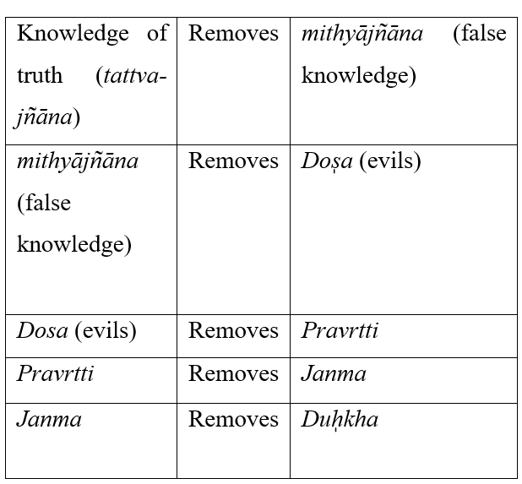
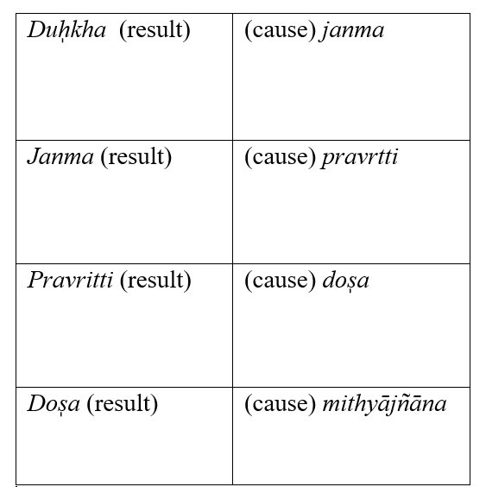
Table: The cause of life (left) and the process of liberation (right)
Gautama, in his first sūtra, discussed the nature of sixteen categories and their aim for the attainment of liberation. With this very fact, he mentioned the way one can achieve liberation. But this can be valid only through the critical examination. According to him, the ultimate cause of life and suffering is mithyājn͂āna. He also pointed out that because of the false knowledge one gets at birth. The essence of mithyājn͂āna is about the kind of knowledge when one thinks that the soul is nothing but his body. These kinds of false knowledge cause the birth. According to Gautama, the removal of mithyajn͂āna leads to the removal of dosa, pravrtti, janma, duh̩kha, and ultimately results in liberation. The suffering of life is only because of birth (janma). One gets into birth because of the merits and demerits of his past actions (karma), which lead to the motivation (pravrtti) of life. The word pravrtti is used here to mean virtue (dharma) and vice (adharma). The cause of this motivation is the kinds of evils (doṣa) that belong to everybody’s life (i.e., rāga or attraction, dveṣa or repulsion, lobha or greed). The occurrences of attraction (rāga) are because of the favorable (anukula) and repulsion for the unfavorable (dveṣa); all these are followed by the false knowledge. That is why one gets into different activities with their own motivations. We have seen that through evil (doṣa) one gets into motivation (pravrtti) which results in the birth (janma), though there are such motivations which result in virtue, for example charity (dāna), rescue (paritra͂na), service to others (paricarana). There are also words which lead to virtue (truth or satya, benevolence or hita, attractiveness or priya, the recital of the Veda or svādhyāya) and minds (mercy or dayā, detachment or asprhā, and reverences or sraddhā). When false knowledge is eliminated by the knowledge of truth, evils are also removed because of the removal of false knowledge. For the removal of evils, motivation too is required to be removed. Because of the removal of the chain, consequent motivation, birth comes to an end. With this cessation of birth, suffering also disappears. Thus, through this disappearance of suffering, the final liberation or niḥśreyasa is attained.
According to Vātsyāyana, knowledge of truth is the very opposite of false knowledge and, as such, negates the latter. However, one can say that false knowledge is also opposed to the knowledge of truth, and it may also negate the knowledge of truth. In reply to this, Uddyotkara mentioned that though false knowledge is generated first, it is weaker than the knowledge of truth because false knowledge has no basis in reality. By contrast, knowledge of truth has the basis of the reality of an object as well as the instrument of valid knowledge (like scripture). Therefore, false knowledge cannot negate the knowledge of truth. Regarding false knowledge, Gautama subsequently mentioned in Nyāya sūtra 1.1.9 that the false knowledge of twelve prameya-s is the root cause of the worldly existence of individual selves. The true cognition of twelve prameya-s essentially leads to the attainment of liberation.
Conclusion
Gautama mentioned that the sixteen categories aim at liberation. Later on, he accepted the fact that it is not the case that after having the true knowledge of sixteen categories, one cannot get liberation immediately, though it cannot be said that for acquiring liberation, there is no role of the sixteen categories. As we have seen before, the knowledge of truth seeks to remove false knowledge (mithyajn͂āna). That is why we need to have true knowledge of sixteen categories to remove the false knowledge of the object's reality. For the cessation of everything else, one must remove false knowledge. The cessation of everything else is a state where one gets the ultimate bliss (śānta). Through the true cognition of situated objects, this reality moves towards the aim of bliss, where all activities turn to an end. And there would be no possibility of rebirth. Therefore, ‘knowledge of truth’ is the only cause of the cessation of suffering and freedom from all consciousness of suffering.

References
Bhattacharyya, S. (1992). Glimpses of Nyāya Vaiśeṣika thought. Indian Council of Philosophical Research.
Chakrabarti, K. K. (1999). Classical Indian philosophy of mind: The Nyāya dualist tradition. State University of New York Press.
Chattopadhyaya, D., & Gangopadhyaya, M. (1967). Nyāya philosophy. Part I (Literal translation of Gautama’s Nyāya-sūtra & Vātsyāyana’s Bhāṣya). Indian Studies: Past & Present.
Dasgupta, S. (1922). A history of Indian philosophy (Vol. 1). Cambridge University Press.
Ganeri, J. (2007). The concealed art of the soul: Theories of self and practices of truth in Indian ethics and epistemology. Oxford University Press.
Gangopadhyaya, M., & Chattopadhyaya, D. (1982). Gautama Nyāya-sūtra with Vātsyāyana’s commentary. Indian Studies.
Gautama. (1915–1919). The Nyāya-sūtras of Gautama: With the Bhāṣya of Vātsyāyana and the Vārttika of Uddyotakara (G. Jha, Trans.; Vols. 1–4). Motilal Banarsidass.
Ingalls, D. H. H. (1951). Materials for the study of Navya-Nyāya logic. Harvard University Press.
Jha, A. K. (2005). Nyāya philosophy, epistemology, and education. Standard Publishers.
Matilal, B. K. (1968). The Navya-Nyāya doctrine of negation: The semantics and ontology of negative statements in Navya-Nyāya philosophy. Harvard University Press.
Phillips, S. H. (1995). Classical Indian metaphysics: Refutations of realism and the emergence of “new logic”. Open Court Publishing.
Potter, K. H. (1977). Encyclopedia of Indian philosophies: Nyāya-Vaiśeṣika and its continuations (Vol. 2). Motilal Banarsidass.
Tarkavāgīśa, P. (1981). Nyāya darśan (Gautama sūtra) with Vātsyāyana bhāṣya (Trans.). West Bengal State Book Board.
Vātsyāyana. (1917–1921). Nyāyadarśana (Gautama sūtra) Bhāṣya (P. Tarkavāgīśa, Trans. & Expl.). Bhārata-Mihira Press.
Vidyabhusana, S. C. (1971). A history of Indian logic: Ancient, mediaeval and modern schools (1st ed., 1920). Motilal Banarsidass.
***

